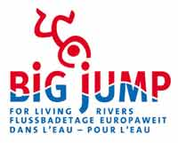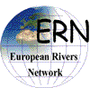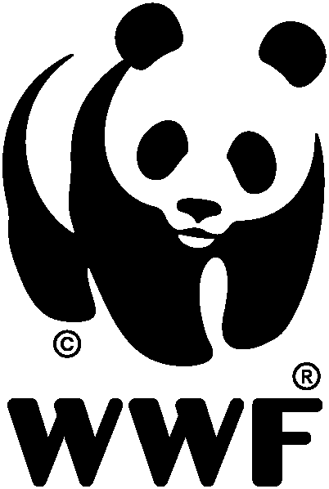

Press release by ERN, WWF, EEB, July 15, 2005

Big Jump, the First European River Swimming Day, 17 July, 2 p.m. (GMT +2)

Jump into Europe’s waters and make EU water policy work

(Brussels, Belgium - 15 July 2005) – On 17 July, at 2 p.m., thousands of people across Europe will take part in a simultaneous "Big Jump" at selected points into rivers, lakes and the sea to claim the right of all European citizens to have access to clean waters. The event, organised by the European Rivers Network (ERN) and supported by the European Environmental Bureau (EEB) and WWF, marks the fifth anniversary of the entry into force of the EU Water Framework Directive.

According to the Water Framework Directive, EU countries have to achieve the goal of a healthy aquatic environment by 2015. But this seems to be a long way away. As a first milestone after the directive came into force, national reports on its implementation are being published this year. These paint a dark picture of the state of the freshwater environment. Fertiliser pollution from agriculture as well as human activities impacting on, for example, the flow, depth and continuity of rivers are some of the main problems.

“More than 50% of all waters across Europe are not in a good condition as required by the Water Framework Directive. Irresponsible agriculture; badly designed navigation and hydropower schemes; water overexploitation; and the careless use of hazardous chemicals in daily products have to end", says Roberto Epple, from the European Rivers Network. “With the Big Jump, citizens call on EU member states to do more to improve the situation of degraded rivers, lakes and coasts. Progress made in certain stretches of the rivers Rhine, Elbe and Thames show this is possible."

"47% of Europe’s citizens are worried about water pollution according to the latest Eurobarometer environmental poll. We have clear evidence that governments not only are doing far too little, but are also reluctant to gather data showing the real condition of our waters and admit the environmental truth", says Melissa Shinn from the European Environmental Bureau. "Decision-makers have not understood yet that such investments will pay off. Citizens will benefit from a cleaner environment as well as healthy food and drinking water”.

“Europe’s rivers, lakes and wetlands provide us with services that have socio-economic values and should be preserved for future generations. These include, for example, natural flood control and water purification as well as groundwater recharge”, says Eva Royo Gelabert European Water Policy Officer at WWF. “With timely and efficient implementation of the Water Framework Directive, Europe will be able to keep on benefiting from such services, save money, create new jobs and grow in a sustainable manner”.

This first “Big Jump” is set to include 200 actions at 30 rivers in over 10 countries from Northern Germany to Croatia, from Portugal to Poland. All events are managed by our regional partners. For information on your nearest “Big Jump” see: www.bigjump.org .

For further information:

- Website: www.bigjump.org (English, French German)

- Roberto Epple, Founder European Rivers Network (Big Jump Initiator ) +33 6 08 62 12 67 or Office France +33 4 71 02 08 14
- Melissa Shinn – EU Policy Unit, EEB European Environmental Bureau, Brussels, . +32 (0)2 289 13 08
melissa.shinn@eeb.org
- Eva Royo Gelabert, Senior European Water Policy Officer, WWF European Policy Office, Phone 02-7438814, email eroyogela@wwfepo.org

Notes to editors:

- The Water Framework Directive (WFD) has been in force since 2000 and aims to protect all European waters (inland surface waters, estuaries, coastal waters and groundwater). Under the Directive, Member States are obliged to prevent further deterioration and to enhance and restore the status of aquatic ecosystems as well as terrestrial ecosystems and wetlands that directly depend on aquatic ecosystems. The purpose is to achieve “good ecological and chemical status” by 2015.

- For the first time an EU Directive has addressed not only the chemical aspects of water protection but also its ecological aspects, such as flow regime, composition and abundance of aquatic organisms etc. This means, for example, that the WFD will help rivers to function like rivers, instead of being mere transport canals, as they have become in many parts of Europe. The Directive thus promotes integrated river basin management – considering the balanced use of all waters draining into a single point from the hills to the sea - as the most efficient way to achieve sustainable water use. This, in turn, requires coordinated planning for using land and water resources within the entire river basin covering all surface, coastal and ground waters as well as land-use activities.

Socio-economic benefits from Water Framework Directive implementation include: protection of human health through better quality of drinking and bathing waters; lower costs for water uses by reducing treatment and remediation costs (e.g. drinking water supply); mitigation of impacts from climate change and ensuring security of water supplies; promotion of new sustainable jobs (e.g. in ecotourism, fisheries and nature conservation sector); and improvement of the quality of life by increasing the recreational value of surface waters (e.g. for water-sports).

- Link to the WWF and EEB WFD “Snapshot” Report on the quality of national transposition and implementation of the Water Framework Directive at the end of 2004, which shows some countries’ first estimates of the percentage of waters at risk of failing to meet the WFD objectives by 2015 resulting from the WFD first River Basin District characterisation and risk assessment http://www.panda.org/about_wwf/where_we_work/europe/what_we_do/policy_and_events/epo/initiatives/freshwater/publications/index.cfm

- Link to the official WFD implementation web sites of the EU Member States, where WFD first River Basin District characterisation and risk assessment reports can often be found: http://www.europa.eu.int/comm/environment/water/water-framework/links.html

