TAGLIAMENTO -

„THE KING OF WILD RIVERS“
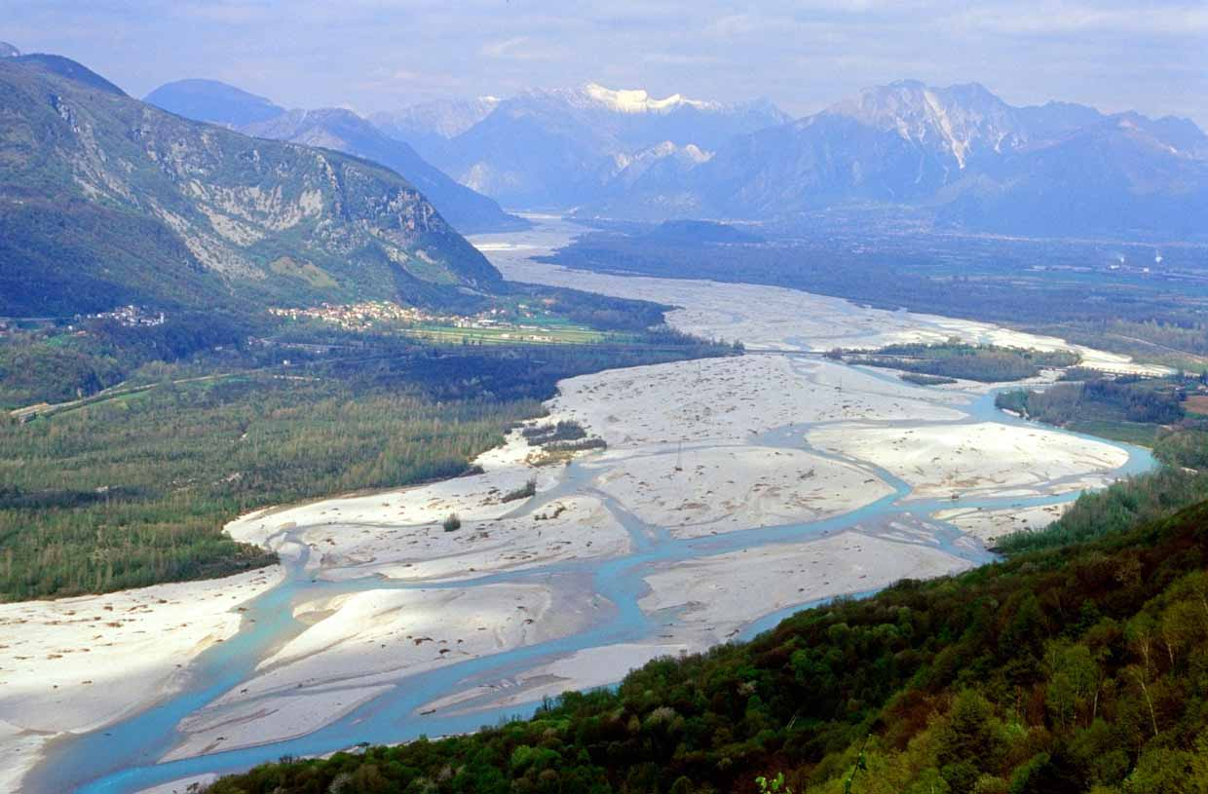
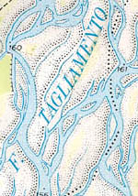

Promoting a European initiative for the protection of the largest wild river in the Alps - the Tagliamento in Northern Italy

A EUROPEAN RIVER CORRIDOR -
CONNECTING THE ALPS WITH THE
ADRIATIC SEA
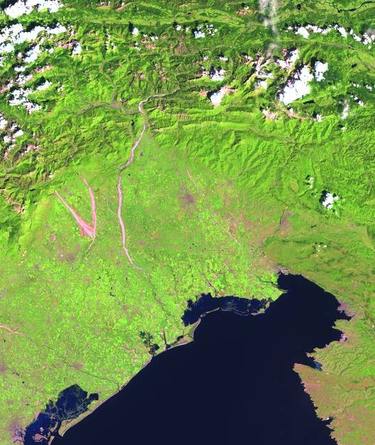
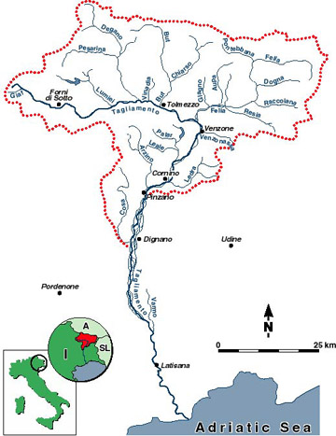

The Tagliamento as a white band
(Map credit: Dr. Dave Arscott)

A NET OF RIVER ARMS AND ISLANDS
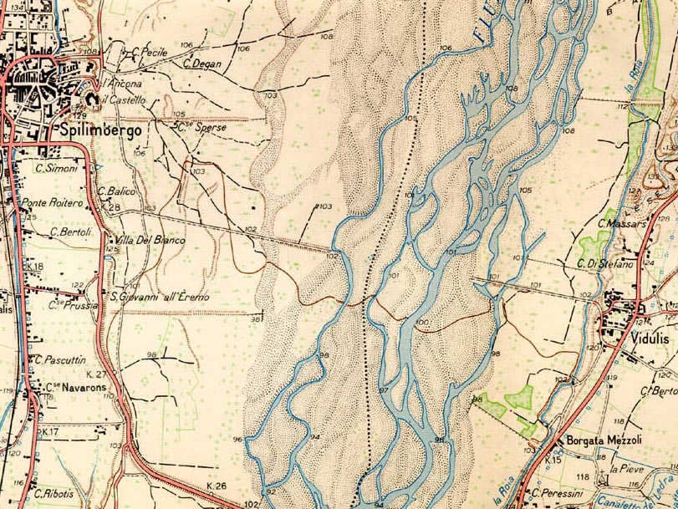
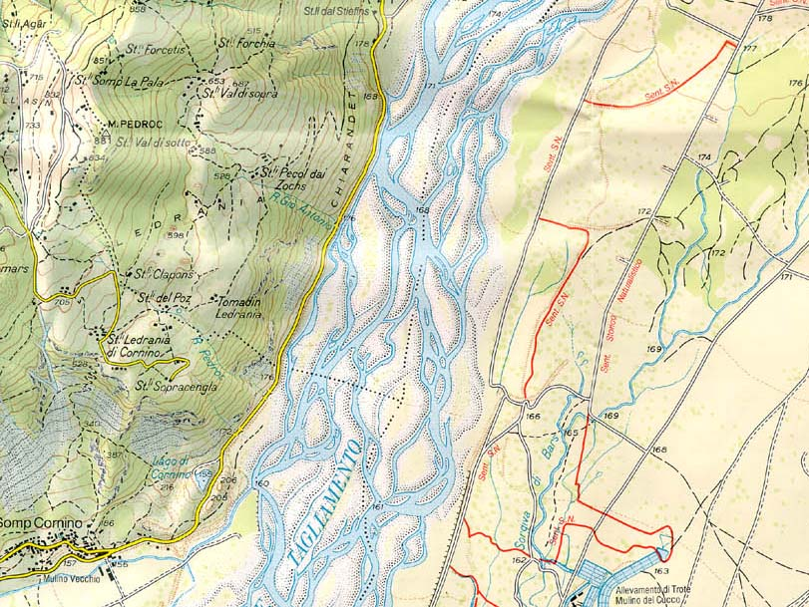
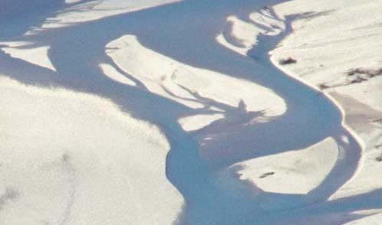

NATURA 2000 SITE AND AREA OF THE PROJECTED RIVER REGULATION SCHEME

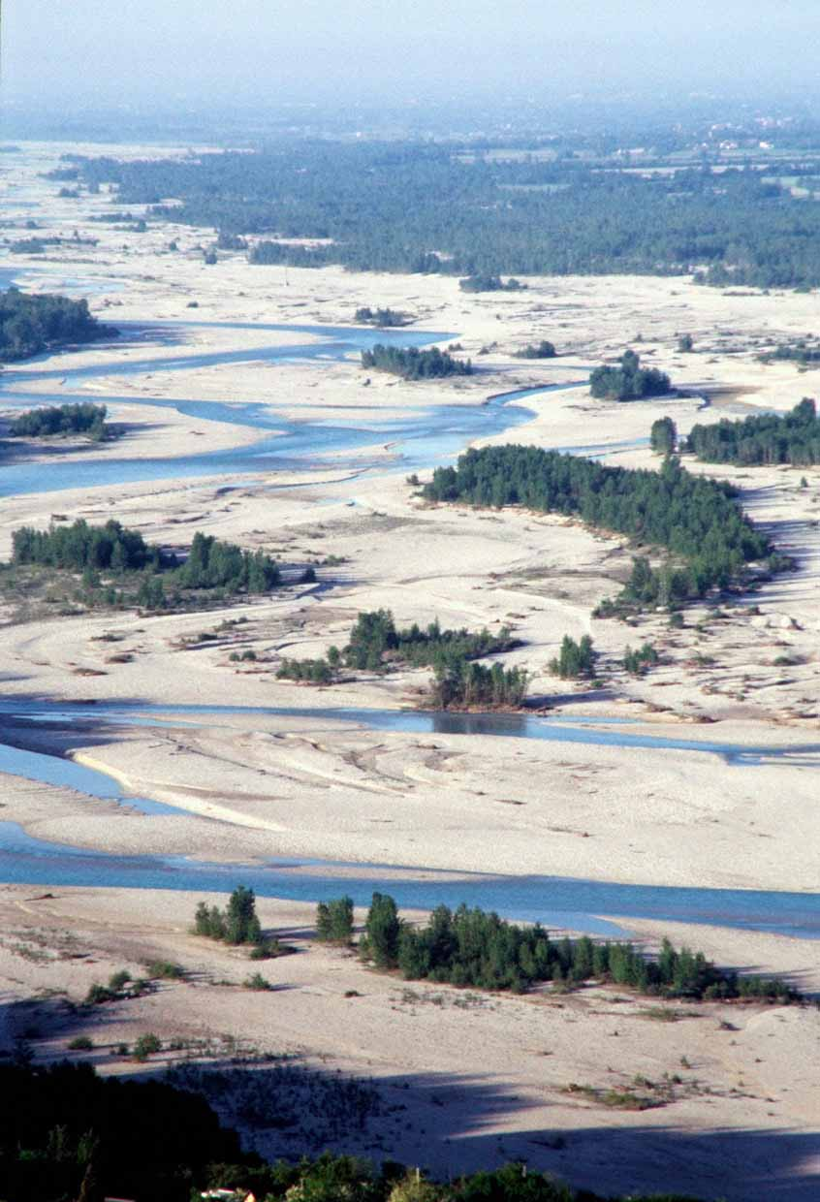
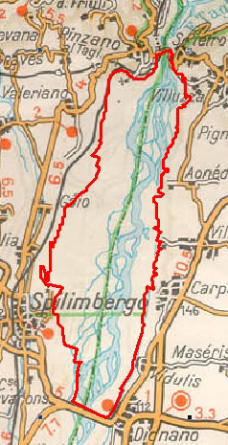

Natura 2000 site “Greto del Tagliamento” (2712 ha)
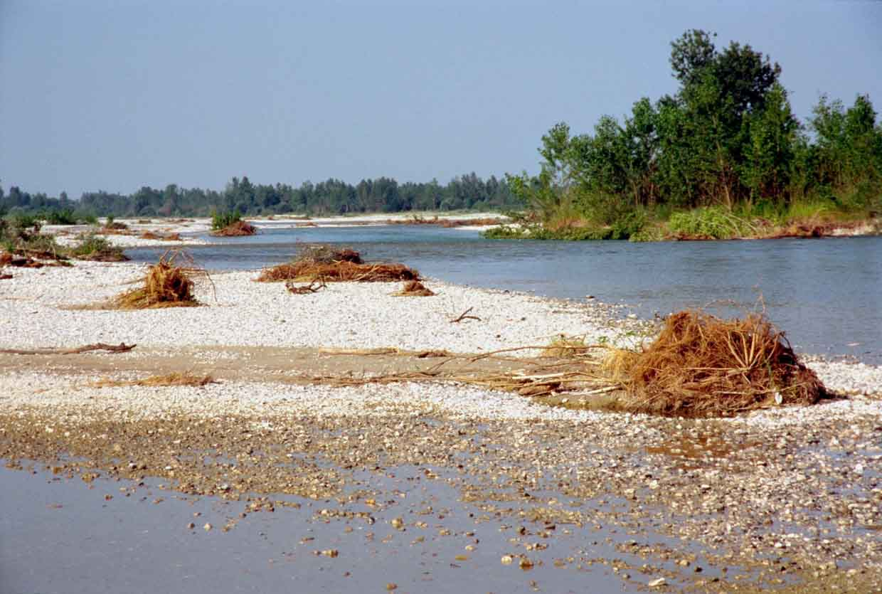
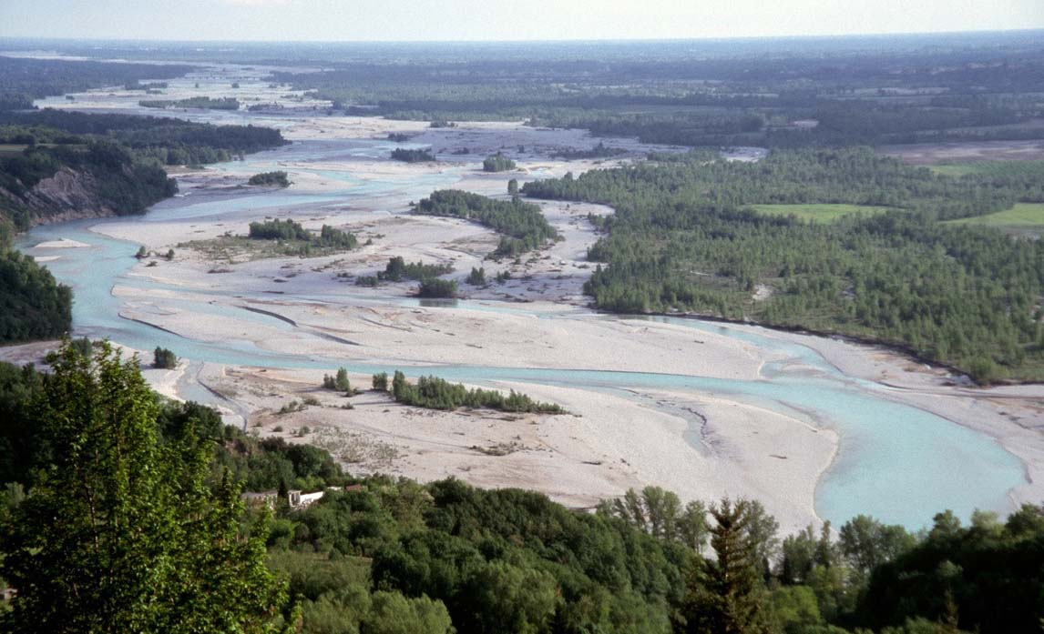

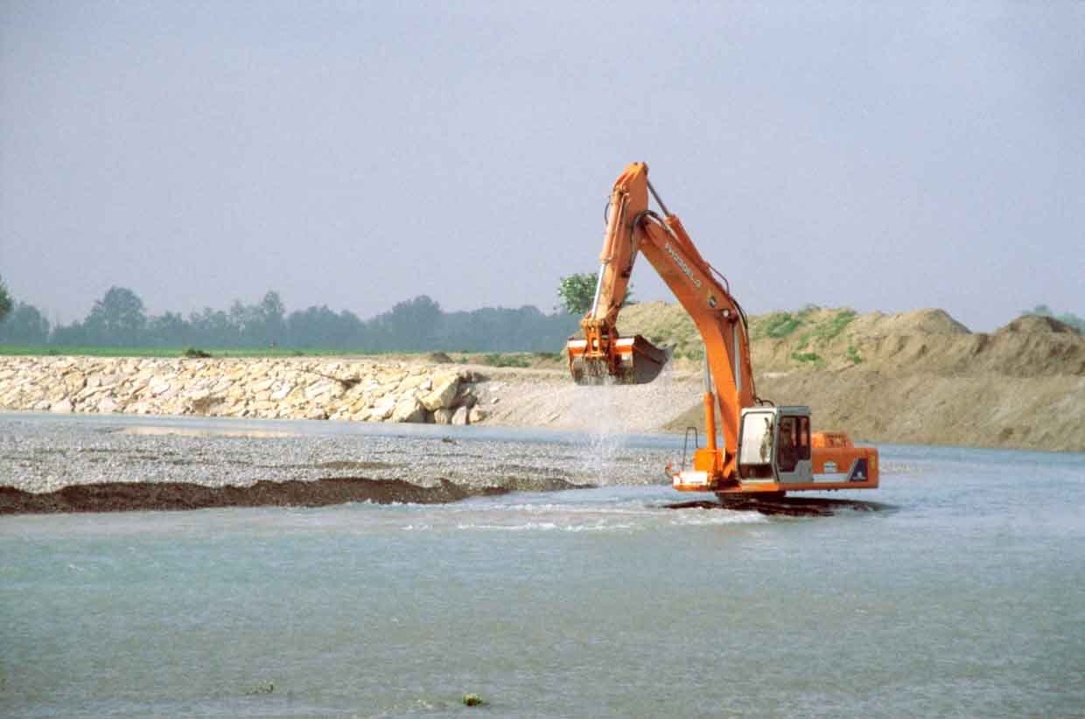

FROM AN ENDANGERED RIVER TO A PROTECTED EUROPEAN LIFELINE

FROM VISION TO REALITY –
“BIOSPHERE RESERVE FIUME TAGLIAMENTO”
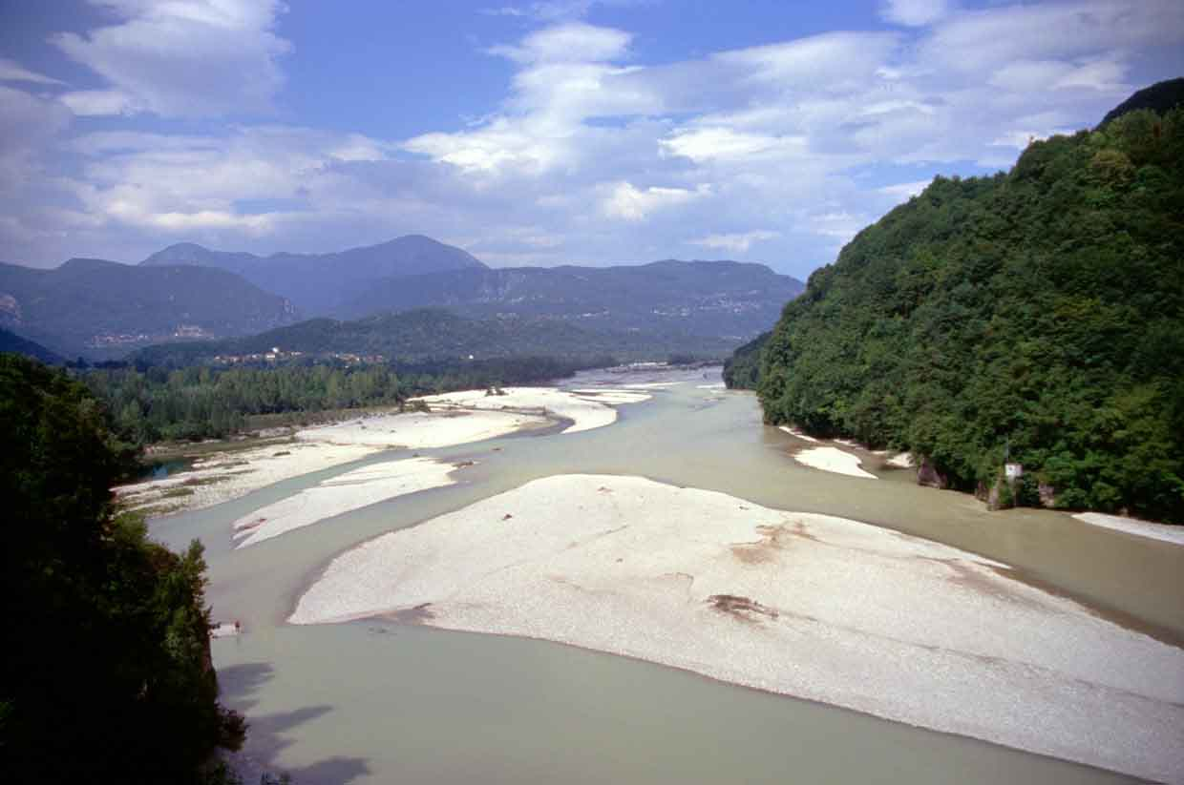

LET´S TAKE ACTION
FOR A LIVING TAGLIAMENTO!

Contact:
Nicoletta TONIUTTI
WWF Friuli Venezia Giulia
I-33100 Udine
tel. 0039-0432-502275
email: pitao@inwind.it

Photo credits and document preparation: A. MOHL/ WWF A (available via arno.mohl@wwf.at)

